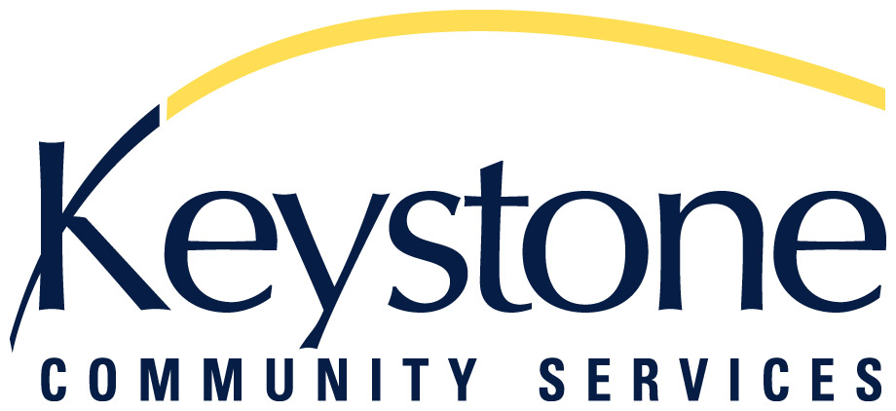

ONEIDA SCHOLARSHIP FUND

GRANT APPLICATION FORM

Please complete the application form and submit it with at least two recommendation forms, most current high school or post secondary transcripts and proof of income to:
Keystone Community Services, Attn: Julie Murphy, 265 Oneida Street, Saint Paul, MN, 55102.

All material should be neatly printed or typed. Incomplete applications will not be considered. Applications are not complete until recommendation forms, transcripts and proof of income have been received. Applications, recommendation forms, transcripts and proof of income must be postmarked no later than September 11, 2020.

STUDENT DATA
1. Name:

______ ____ _____
Last First Middle

2. Home Address:

Street City State Zip

3. Telephone Number: ( ) 4. Date of Birth
Area Code Number

5. Email Address: _________________________________________________

FINANCIAL DATA

1. Are you listed as a dependent on someone else’s tax forms? (Circle one) YES NO

2. Number of total people living in the household: ____________

3. Annual Household Income: List each household member below including children. Document income for each adult household member. Enclose proof of income for each member: one month’s pay check stubs, letter from employer stating wages, copy of annual tax return, copies of Unemployment, MFIP or SSI benefits, etc...
Annual Child Government Other
Household member name: employment SSI Support Support Income
1.
2.
3.
4.
5.
6.

4. Total Annual Household Income:_________________________________

EDUCATION PROGRAM DATA

1. Type of program you will be using the grant for (undergraduate programs only):

Baccalaureate (BA/BS) Associate Degree (AA)
Training Program (describe) ____________________________________________________

- School or Program Name and Address:

Name

Street City State Zip

3. You must be currently accepted and enrolled in a program for 2020-21.
Are you currently enrolled? (Circle one) YES NO

4. Program Completion Date: Month Year

5. Area of study/training is

6. Please describe how you will use this grant. Attach additional sheets if necessary.

7. Please describe your educational goals and what influenced you in setting these goals. Attach additional sheets if necessary.

8. How are you currently involved in your community and how do you currently contribute to community? Consider community in its broadest sense. This could be a geographic community but it could also be a community of school, faith, culture, etc. Attach additional sheets if necessary.

9. How will accomplishing your educational goals enable you to further contribute to a community?

10. Are there any special circumstances which affect your ability to complete your education/training
program and produce higher need for assistance? Attach additional sheets if necessary.

11. Are you related to any staff person or Board member of Keystone Community Services?

(Circle one) YES NO Who ____________________________

Please send the completed Application Form, a current transcript from the program you are attending and proof of income to:

Keystone Community Services  Attn: Julie Murphy  265 Oneida Street  Saint Paul, MN 55102 | Phone: 651-504-2246  Fax: 651-298-5729  Email: jmurphy@keystoneservices.org
Please instruct those who are writing your TWO letters of recommendation to mail or email them directly to the same address by the due date.
KEYSTONE COMMUNITY SERVICES

ONEIDA SCHOLARSHIP FUND
GRANT RECOMMENDATION FORM

Student's Name:

In your recommendation of the above named student, please consider that the following items will be evaluated by the Selection Committee: quality of academic/skilled work; contributions within the community; educational goals and post-education plans, and any special circumstances affecting this student's completion of their education. Attach additional sheets if necessary. Applications will not be considered complete until recommendation forms are submitted.

How long have you known the applicant? _______________________________________________

_________________________________________________________________________________
Signature Printed Name

_________________________________________________________________________________
Telephone Email Position

_________________________________________________________________________________
Address

Please mail the completed recommendation form to: Keystone Community Services, Attn: Julie Murphy,
265 Oneida Street, Saint Paul, MN 55102 postmarked no later than September 11, 2020 or email to jmurphy@keystoneservices.org.
KEYSTONE COMMUNITY SERVICES

THE ONEIDA SCHOLARSHIP FUND
GRANT RECOMMENDATION FORM

Student's Name:

In your recommendation of the above named student, please consider that the following items will be evaluated by the Selection Committee: quality of academic/skilled work; contributions within the community; educational goals and post-education plans, and any special circumstances affecting this student's completion of their education. Attach additional sheets if necessary. Applications will not be considered complete until recommendation forms are submitted.

How long have you known the applicant? _______________________________________________

_________________________________________________________________________________
Signature Printed Name

_________________________________________________________________________________
Telephone Email Position

_________________________________________________________________________________
Address

Please mail the completed recommendation form to: Keystone Community Services, Attn: Julie Murphy,
265 Oneida Street, Saint Paul, MN 55102 postmarked no later than September 11, 2020 or email to jmurphy@keystoneservices.org.

